GRAPEVINE

Winter Edition
2018/19
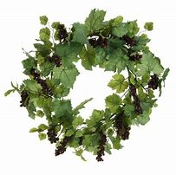

St George’s Anglican
Episcopalian Church
Nuñez de Balboa, 43
28001 Madrid

(Metro VELAZQUEZ – Line 4)

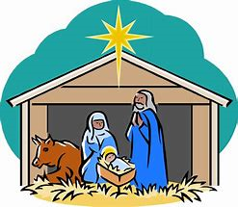

Services

Sundays 08:30 am Holy Communion
10:00 am Family Eucharist
10:00 am Godly Play (Sunday School)
11:30 am Sung Eucharist
11:30 am Sunday School
(as announced)

Fifth Sundays 08:30 am Holy Communion
11:30 am United Service
No Sunday School

Wednesdays 19:30 pm Evening Prayer

Fridays 10:00 am Holy Communion

Tel: +34 91 576 5109
Email: info@stgeorgesmadrid.com
Web site: www.stgeorgesmadrid.com
Chaplain: The Revd. Paul Ormrod
Follow us: www.stgeorgesmadrid.com
OR facebook.com/stgeorgesmadrid
MESSAGE FROM THE CHAPLAIN Fr Paul

Farewell

Jill and I have enjoyed our time at St. George’s Madrid enormously and now the time is fast approaching to say good bye. We both have a strong sense that God is calling us to our new ministry at St. John’s Montreux in Switzerland, but there is no doubt that we shall miss everyone at St. George’s. We shall certainly continue to remember you all in our prayers.

The life of the Church depends not merely on the Chaplain but on all of us, together, offering our prayer, our commitment, our service to Christ in whatever ways we can day by day so that the Jesus Way may be offered to all. I know that our congregation is faithful and prayerful and I know that, however long the Vacancy, you will be served by our Church Wardens, Anne and Rebecca, as they in turn will be supported by you.

But what I really want to ask of you is this: will you double and redouble your efforts to invite others to join us? It is very tempting for a congregation in a Vacancy to turn a bit inwards, to worry about “keeping things going” and to forget that our primary ministry is twofold: both committed worship and committed outreach so that others may know they are loved by God, that others may know Jesus died for them. Will you do that?

FORTHCOMING SERVICES AND EVENTS

13th December Concert in Church by the Madrid International Choir.

15th December 11:00 – 20:00 Christmas Bazaar

16th December 18.30 A service of nine lessons and carols

23rd December 18.30 Holy Communion at El Escorial

24th December 16.30 Family Service and Christingle
23.30 Midnight Eucharist

25th December 11.30 Sung Eucharist with carols

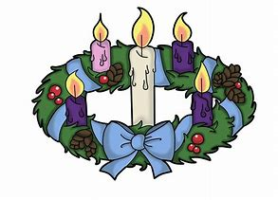

50 YEARS OF CHRISTINGLE

The idea of the Christingle began in Marienborn, Germany in 1747. At a children’s service, Bishop Johannes de Watteville of the Moravian Church looked for a simple way to explain the happiness that had come to people through Jesus. He decided to give the children a symbol to do this. It was a lighted candle wrapped in a red ribbon. At the end of the service, while the children held their candles, the bishop said the prayer, “Lord Jesus, kindle a flame in these children’s hearts that theirs like thine become.”

In 1968, John Pensom of The Children’s Society adapted the tradition and introduced it to the Church of England. It involved children decorating an orange with red ribbons, dried fruits, sweets and a candle to create a new visual representation of Christ, the light of the world, celebrated by the lighting of the Christingle candles.

The first Christingle service in the UK was held at Lincoln Cathedral on 7 December 1968. Only 300 people were expected to attend, but as many as 1,500 turned up. The popularity of Christingle services has grown since then, attracting generations of children and families to this well-loved Christmas tradition.

We hope to see you at St. George’s at 4.30pm on Christmas Eve.

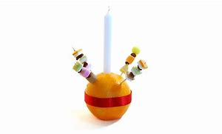

NATURE NOTES by Elizabeth Pacey

The cold of the real winter is beginning to bite in the Sierras and it seem a long time since the migrants of last spring and summer began to arrive with their exuberant songs and colour, putting the local birds in the shade.

The resident long tailed tits were the first to nest, successfully raising two babies in an alarmingly open branched pine. How the magpies didn´t get to them we´ll never know – too prickly perhaps. By then the early visitors were arriving. A pair of swallows returned to nest in the garage as last year, built an extension, redecorated and raised a family of five. To see them swooping through the very small space left in the slightly open garage door was amazing. Their aerobatics never ceased to delight. Then the nightingales, two males, kept us awake for a short spell before finding mates and settling down to breed and not wake the babies – or us. A week or two later a Dartford warbler came and made it´s nest in the lavender, the same place used by them for the past four years, incredibly surviving the cats, hopefully adults or young will return next spring.
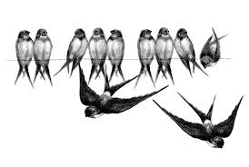
The oriels signalled their arrival with their lovely fluting song, and brilliant flashes of colour. The lime green females and acid yellow and black males were very eye catching as they zipped across the garden. And despite the cats, a hoopoe could be seen jumping around under trees. Note to ourselves; remember to keep the cats well fed!

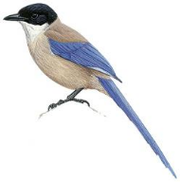
As the fruit began to swell and slowly ripen, a large flock of azure winged magpies took up residence. They are such lovely birds, without the bad manners of ordinary magpies, that we couldn’t begrudge them the fruit as they tucked in to pears and plums. There was plenty for us all and they were such tidy eaters clearing up fruit on the ground when it fell. Eventually even they had eaten enough, leaving the grapes to the blackbirds who are so clever at getting through the “protective” netting.

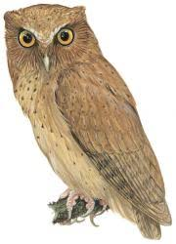
During the cooling nights we could hear the owls; the tiny but noisy scops, a little owl and a tawny calling as they hunted, mostly from some distance away. The lavender´s final flush brought even more bees and butterflies, although we missed the usual number of swallow tails. More missing friends during the summer were the robins, but by the end of September we had a pair of cheery neighbours waiting for worms on the compost heap. The regular bed and breakfasters have remained loyal; tree creepers, woodpeckers, nut hatches, various tits, sparrows and starlings will stay despite rain, wind and snow. Time to get out the coconut, seeds and suet to help them through the barren months until the sun begins to warm us all like a phoenix rising with the spring.

THE REALITY OF OUR FAITH

‘The Word became flesh and made his dwelling among us. We have seen his glory, the glory of the one and only Son, who came from the Father, full of grace and truth.’ John 1:14, from the Gospel for Christmas Day.

Do the words of the Gospels become too familiar to us? Those who were brought to Church or Sunday School by their parents first heard them long ago, and the celebrations that surround Christmas leave memories that drive them out of context. We remember the wrapping and tinsel but not the content. That high-ranking luminary of the religion of secular humanism, Richard Dawkins, likened beliefs such as ours in Jesus Christ to a child hoping for the visit of the Tooth Fairy.

The majority of people (called by CS Lewis ‘the massive chorus of agreed and admitted unbelief’) have been left with an inheritance that means that our faith is regarded as being something for the unenlightened, long ago shown to be a figment of the imagination. But they ignore the reality. Far from fiction, our beliefs are anchored in a series of events in history, well documented and beyond reasonable doubt. The apostle Peter wrote, ‘We did not follow cleverly invented stories when we told you about the coming of our Lord Jesus Christ in power but we were eye-witnesses of his majesty’ (2 Peter 1:16) Two verses later he refers to a particular episode, the Transfiguration, ‘We ourselves heard this voice from heaven when we were with him on the sacred mountain’. John, who, as quoted above, ‘saw his glory’ starts his first letter, ‘That which was from the beginning, which we have heard, which we have seen with our eyes, which we have looked at and which our hands have touched – this we proclaim concerning the Word of Life’. That’s reality!
The fact is that the birth, death and resurrection of our Saviour, Jesus of Nazareth, are as well recorded, and as well documented, as the birth and death of any other person in history. Nobody doubts the facts of the lives of Plato, Julius Caesar or Winston Churchill, for example. In the case of the latter there are plenty of people still alive who saw him, heard him and some who talked with him. Just as it was in the 1st Century when Paul (the Apostle not the Chaplain!) was converted in so dramatic a manner. This is described three times in the book of Acts and was constantly in Paul’s mind and referred to in his letters. In 1 Corinthians 15: 3-8 he lists individuals and groups, one of more than 500 people, who saw the Risen Christ, most of whom, at the time he wrote, were still alive and could be asked about their experience.

It transpires that it is those who ignore these facts of history who are chasing after fantasies, not us. See through the wrapping and the tinsel. Our beliefs are firmly anchored in history and this reality must inspire us who know Jesus as his disciples to seek to follow him more closely, and to turn to his Word more assiduously to learn the means to do so. Think about it and take action!

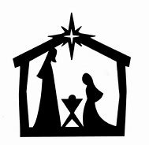

MUSEO TIFLOLOGICO By Callie Stewart

After the November talk in St. George's Guild, Patricia Andrea, who is a friend of ours here at St George's, organised a visit for us to the Museum Tiflologico. It's a ‘touch and see’ museum which helps blind people to 'see' famous monuments from all over the world.

Patricia is a very able guide there and explained some of the models to us; the layout of Jerusalem for example.
Then with half of us blindfolded we tried to recognize some monuments by touch. Not easy I can assure you!
The Museum is well worth a visit.

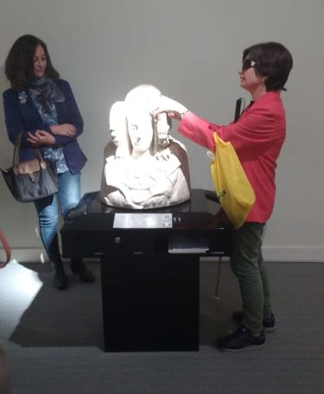
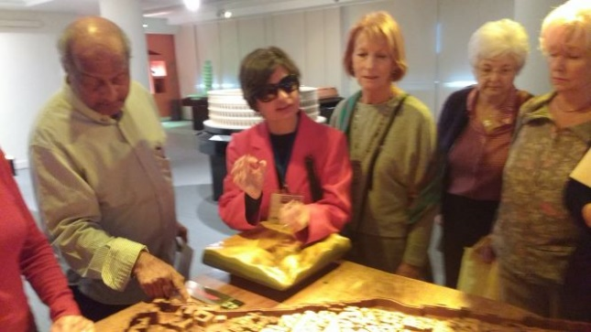

MY CAMINO DE SANTIAGO DE COMPOSTELA by Melissa Pearce

I had wanted to walk to the Camino de Santiago de Compostela for a long time, and at the start of this summer, I had my chance. A very good friend of mine had decided to do it and I jumped in straight away and offered her my company. We set about making our plans.

We decided to do the Camino de Francés, which actually starts in the south west of France and is the most popular route. As we both have families and many commitments at home, we could only afford to dedicate about 9 days to our adventure but felt this was enough. We decided to start at O’Cebreiro in the province Galica; a beautiful and tiny village high up in the mountains with the most amazing views. By starting here, we would get to walk about 170 kilometres to the finish in Santiago de Compostela – almost the entire width of the province.

After lots of research, we were packed – plastic bags, flip flops, head torch, walking sticks, good quality socks, a pillow case and a buff (a multi-use headscarf that can be used as a head band, scarf, hat, eye mask, nose mask and all sorts!), all of which we ended up needing and proved to be very useful!

The day had arrived!! We caught the train from Chamartin in Madrid, changed at Palencia and got on to another train to Ponferrada; then a bus to Pedrafita de O’Cebreiro. From there we were picked up by the guy from the pensión where we were staying that night. He was a welcome sight after 9 hours of travelling just to get to the start!

We were now driving through hills and mountains full of luscious green grass and trees! It was beginning to look like England. O’Cebriero was a delight! Our new friend and driver, Anton, helped me get straight to the village church which was about to close, to obtain my Pilgrim’s passport that I was going to need all the way along the Camino.

The Pilgrim’s passport proves that you have done the walk by collecting at least two stamps each day from various places along route. Bars, cafés, albergues all provide their own special one. And with this completed passport, you can obtain your certificate upon arrival in Santiago.

That first night set us up nicely for our week ahead and it was certainly a sign of things to come while we sat on stumps of wood outside our Pensión with people from all over the world; all pilgrims. Some just starting, some already two-thirds of the way through and everyone else in between. One guy had brought his guitar and we sat round, drinking beer (Estrella Galicia of course!) and singing songs. ‘This is going to be amazing,’ we thought!

The next day we got up early. We left before sunrise and already the village was busy with pilgrims setting off. It was so exciting, heading off in the dark, following the yellow arrows and there are plenty of them. We did well on our first day, hiking through forests, along rough paths, uphill and downhill, always accompanied by the most beautiful and tranquil scenery. We were delighted to find our first Albergue for that night’s stay. Our feet were sore and our bodies were tired, but we had arrived in time for lunch. We soon picked up valuable advice from the other pilgrims – bathe your feet and legs in the icy cold water of the nearest river! This is where the pilgrims gather after a long hike. We went into the river right up to our thighs, it was freezing!! But such a relief!

By the third night we were getting into a routine; setting off before sun rise, finding some breakfast after about an hour of walking, and then hiking to the next location in time for lunch. After an afternoon siesta, we would go out for a small dinner and be in bed by 10pm, ready for a good night’s sleep.

Throughout our pilgrimage, we were always surrounded by other walkers, other pilgrims on the same route but undertaking their own individual journey. One never felt alone, although always caught up in one’s own thoughts and contemplation.

We soon found we were meeting the same people day after day and got to know some familiar faces. We would stop and ask each other how we were getting on. One Irish brother and sister team had lost their father and were getting worried – we found out later that day that they had eventually found him again!

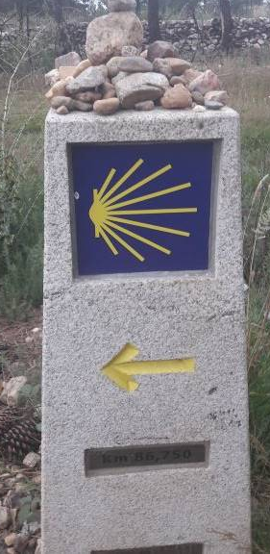
Every day, we walked great distances through forests and mountains, shared stories, got blisters and tired legs, slept in dormitories with bunk beds in rooms of 10 or 14 people we didn’t know, but somehow sharing something very magical. We found ourselves talking and sharing inner thoughts; opening our hearts with raw emotion, experiencing spiritual moments, eating, sleeping, walking and sharing all of this with strangers, who were becoming our new friends. I learnt about the different reasons why people wanted to do this pilgrimage, whether for religious, spiritual or for fitness reasons.

Each day provided us with beautiful landscapes, enchanting scenery and challenging terrain. There were other surprises too – one day an old lady appeared from her house with a big pile of freshly made pancakes and was offering one to each weary looking pilgrim that passed by.

There were lots of places of refuge to rest, to eat, to use the bathroom or top up water bottles at. One particular place was very welcoming, everyone received a hug as we staggered in, exhausted. It was run by a group of volunteers who were handing out water, coffee, advice or a friendly ear. There was a group of people inside singing and playing the guitar.

Another such place was a small pub with a beer garden. Every pilgrim who passed by was encouraged to buy a bottle of local Peregriña beer (Peregriño/a, meaning Pilgrim). Once you had drunk the contents and your bottle was empty, you could decorate the bottle with thoughts, messages, or simply the names of your loved ones and the date. And then you found a little place in the beer garden to leave it behind for others who followed behind you to read. The garden was full of thousands of decorated beer bottles and the owners had created a “Door of confession” out of them.

Not far from this stop, was another ‘must see’ landmark. Another pilgrim’s bar called Casa Verde. Inside, the very lively pub was absolutely covered in memorabilia from previous walkers of the Camino. There were hand written messages of encouragement all over the tables, the ceiling was full of t-shirts, caps, hats, scarves and bits of material laden with names, messages and dates. It was awesome and gave us a sense of camaraderie.

Of course, a very common sight was the numerous churches we passed along the way; in villages, towns and some in the middle of nowhere. These too, were places of refuge, rest and calm. The pilgrims who had walked this route over hundreds of years before us would have stopped here for water, food or shelter. We would stop sometimes to say a prayer or light a candle or to simply rest.

On the last day of walking, about 5kms outside of Santiago, we stopped for a while at the top of Monte de Goza. From here you get your first sight of your final destination, La Catedral de Santiago de Compostela (the Cathedral), with its dominant spires and majestic presence reigning over the landscape. It was a time to pause for a while, take in what he had achieved, reflect on our experiences and prepare ourselves for the final steps of our journey.

As we entered Santiago itself our excitement increased and so did our speed! We just wanted to get to the cathedral then. There were so many other pilgrims around us, all heading in the same direction, all gathering momentum, all wanting to get to that plaza where the cathedral so famously and dominantly stands. We got into the old town and the pavements were buzzing with tourists, families, locals, musicians and pilgrims filling the narrow medieval streets.

As we got really close, my friend and I suddenly had the urge to hold hands, to enter this spiritual home precisely at the same time! We had endured all the highs and lows of this journey together and it was how we were going to complete it!

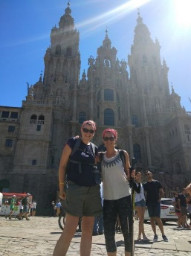
Just as we were taking our photo in front of the famous cathedral, we bumped into the friends we had shared a room with. We all congratulated each other and celebrated over the best tasting beer ever! We were all absolutely elated. The pain was worth it.

Before long, we had created our own WhatsApp group – which we still have. We had shared something incredibly special. And I believe, everyone should do it!

VASCO NUÑEZ DE BALBOA by Torsten Archer

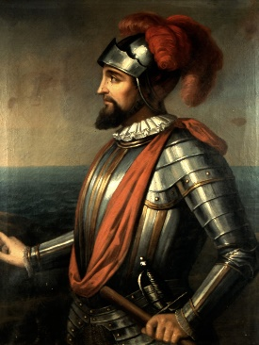
Roads throughout the city of Madrid are named after individuals. However rarely do we wonder who these people are. Therefore, this article explores the character of Nuñez de Balboa, whose name is enshrined on the road of our church.

He was born in Extremadura in 1475 to a family of the lower nobility. In 1500 he first travelled to the New World and took part in an expedition exploring the coast of modern day Colombia. He then settled on the island of Hispaniola (modern day Haiti and the Dominican Republic). However, he fell into debt and was forced to flee the island. In 1510 he escaped on a ship belonging to Martin Fernandez de Enciso. This ship was transporting supplies to a settlement in modern day Colombia. After Nuñez de Balboa was discovered he had to use his charisma to convince Enciso not to maroon him.

When they arrived on Continental America there were only a few survivors from the former settlement left as many had been killed by the local people. At Balboa’s suggestion they moved to a new settlement called Santa Maria de la Antigua. Balboa then managed to orchestrate the deposing of Enciso, stating that it was outside the domain that the royal charter gave him authority over. Balboa had taken control, and this state of affairs was affirmed by King Ferdinand in Spain. He then set about using a divide and rule strategy to conquer the area. He also took large quantities of gold from the local population. He was informed by natives about richer areas to the South and a ‘sea’. In 1513, Balboa launched an expedition in search of gold and the ‘sea’; the Pacific (or as it was called at the time, the South Sea). He would be the first European to see the Pacific.
During his absence King Ferdinand had installed Pedro Arias Davila in Santa Maria, however Balboa was made governor of the territories that he had explored on the Pacific coast. Nonetheless, he was placed under the control of Davila. Tensions between the two men quickly rose with Balboa being more popular among the settlers. In 1517, Balboa continued exploring after transporting ships across the Isthmus of Panama. Allegations against Davila resulted in King Ferdinand sending a commission to investigate him. Hearing news of this, Davila had Balboa arrested by Francisco Pizarro (who would later conquer the Inca Empire in Peru) as it was likely that Balboa would contribute to the case against him. Davila then staged a trial which resulted in Balboa being beheaded in January 1519.
Balboa is nowadays often placed in a higher regard compared to many of his compatriots who are primarily remembered for their cruelty. He is often considered to have been a fair and popular administrator. He also treated the natives reasonably well for the time, although he did take part in numerous atrocities. Today, he is most well known in Panama were the national currency is the Panamanian Balboa.
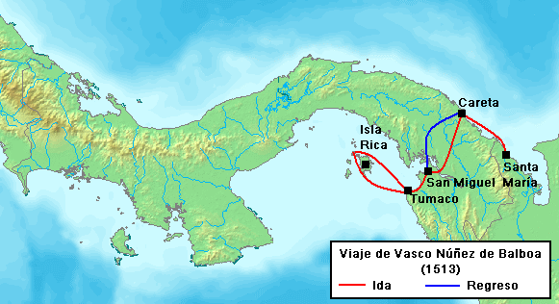

The Church Council:

The Chaplain: The Revd. Paul Ormrod
Reader: Celia Paterson
Vice-chair: Celia Paterson
The Church Wardens: Anne Cole
Rebecca Rico Irwin
Synod Reps: Celia Paterson
Elizabeth Pacey
Jenny Effer
Honorary Treasurer: Karen Mullins

Elected Members: Carol Skinner, Jill Ormrod, Ngozi Ajero, Karen Mullins, Rebecca Rico Irwin, Adam Hill, Melissa Pearce

Church Flowers: Louise Bueno
Director of Music & Organist: Stephen Knight
Deputy Organist: Diana Davies Burr
Secretary Church Council: Anne Cole
Safeguarding Officer: Anne Cole

