GRAPEVINE

Spring Edition
2019

St George’s Anglican
Church

Nuñez de Balboa, 43
28001 Madrid

(Metro VELAZQUEZ – Line 4)
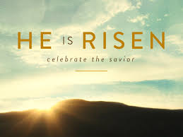

Services

Sundays 08:30 am Holy Communion
10:00 am Family Eucharist
10:00 am Godly Play (Sunday School)
11:30 am Sung Eucharist
11:30 am Sunday School
(as announced)

Fifth Sundays 08:30 am Holy Communion
11:30 am United Service
No Sunday Schools

Wednesdays 19:30 pm Evening Prayer

Fridays 10:00 am Holy Communion

Tel: +34 91 576 5109
Email: info@stgeorgesmadrid.com
Web site: www.stgeorgesmadrid.com
Locum: Bishop Henry Scriven
Follow us: www.stgeorgesmadrid.com
OR facebook.com/stgeorgesmadrid

MESSAGE FROM OUR LOCUM CHAPLAIN

St. George’s Church - 24 years on

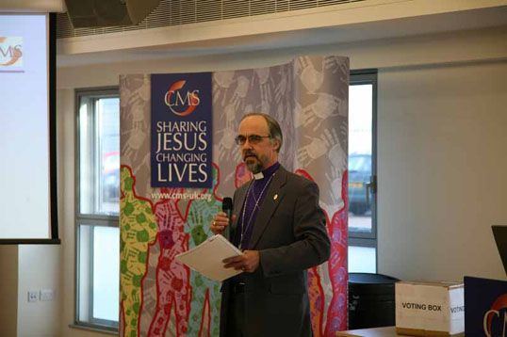
What is the greatest need in St George’s church? I think it is the same need as throughout the Anglican Communion: Intentional Discipleship. There are many of us who for a variety of reasons just come to church whenever they can, enjoy the familiar liturgy, the music, maybe even the preaching (!) and of course the social time after church; and that sums up our Christian life and commitment. But Jesus never intended for us just to be church-goers; his command was to go and make “disciples”. But what does that actually mean?

Well the Greek word means “learner”; a follower of Christ who constantly learns about the faith and seeks to make other disciples. In 2016 the Anglican Consultative Council met in Lusaka and launched a Season of Intentional Discipleship until 2025. Their definition is: Discipleship is about equipping Christians to live their everyday lives as followers of Christ, following his example and teaching. It is about putting faith into practice and training other believers to do so too. It is about mentoring and encouraging believers so that their faith has an impact on the world around them. Anglican Communion church congregations and dioceses are working, worldwide to discover what this means in each local context and culture.

How can St George’s join in with this intentional movement? It must involve having other things going on; not just Sunday services. What are the chances of getting together with friends and neighbours for a Bible Study group in someone’s home? How can we better support the practical mission of the church to bring justice and peace, to feed the hungry and relieve the oppressed? These things should not just be led from the top. Ideally it should be possible for individuals to take the initiative and start small groups.

The Communion has produced resources:
https://www.anglicancommunion.org/mission/intentional-discipleship/discipleship-path/on-the-road/adults.aspx
https://www.anglicancommunion.org/media/316877/Bible-study-booklet-2018.pdf

Why not take the initiative; see if you can form a group to study and pray and learn more about being disciples?

Now here’s a question: apart from Sundays in church, do you consciously and deliberately pray for St George’s and for God’s guidance? Now’s the time to start. Easter is a crucial time in setting the vision for the future.
Another question: is your commitment to St George’s and its future reflected in serious and planned giving of a percentage of your income?
And another: is God calling you to take a more active part in some sort of ministry at church? It could be admin, cleaning, tidying, ecumenical meetings, church council, Godly Play, fundraising, St George’s Guild library and meetings etc.
Finally: have you ever thought of inviting friends who don’t come to church round for coffee or a meal and get the chaplain talk for 5 minutes about some aspect of faith?

St George’s future is not up to the church council, the Lay Minister or the wardens, but the concern of every person who has taken the time to read this far.

What will your commitment be?
Bishop Henry Scriven March 2019
A FABLE AND A MORAL by Renmus

A Chinese farmer needed his horse and his son to work his land. One day his horse ran away to the mountains. The neighbours came to see him to commiserate on his bad luck.

He replied: “Bad luck? Good luck? Who knows?” A few days later his horse returned accompanied by half-a-dozen wild horses from the mountains which the farmer was able to corral. The neighbours congratulated him on his good luck.
“Good luck? Bad luck? Who knows?”

A couple of days later his son was breaking in one of the wild horses when he was thrown and he broke a leg. The neighbours came to sympathise at his bad luck.

“Bad luck? Good luck? Who knows?” Shortly afterwards, a military detachment arrived in the village, rounded up all the young men, forced them to join the army and took them away. All except his son because he was unable to walk. Good luck? Bad luck? Who knows?

Jesus (Matthew 6) (vs25) I tell you, do not worry about your life. (vs:34) Do not worry about tomorrow.
St Paul, (Phillipians 4) (vs11) I have learned to be content whatever the circumstances.

MESSAGE FROM OUR PREVIOUS CHAPLAIN Fr Paul Ormrod

I always said that of all the reasons we wanted to live and work in Madrid, the weather was not one of them. I can truthfully say that the fact we now find ourselves in Switzerland is nothing to do with taking up skiing. In fact, although we have now already been here an unbelievable ten weeks, we have not been near a ski slope. We have, however, made the most of the fact that I am working part-time, and Jill is taking a well-earned sabbatical from teaching, and we have managed to get out and about to explore this part of Switzerland.

In terms of my work as chaplain, it feels very different from Madrid in that we have just one service on a Sunday morning, although as a sung eucharist, it feels very similar to the 11.30 am service in Madrid. We also have a similar arrangement to the El Escorial service, a monthly service on a Sunday evening, although on our first visit we arrived in the middle of a snowstorm.

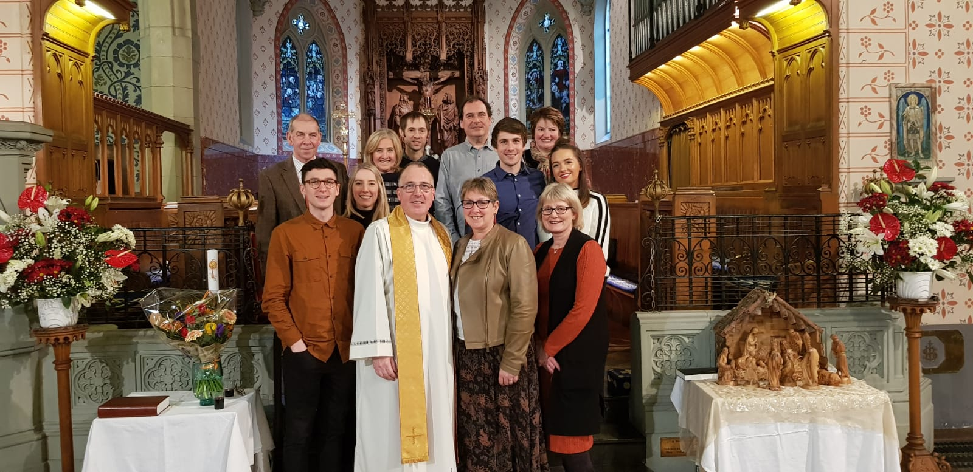
We are beginning to feel settled here now, although we still have a few boxes to unpack. We often think of our time in Madrid with great affection and love to hear news. We will keep you all in our prayers during this period of interregnum. . Every Blessing from Jill and Paul

FORTHCOMING SERVICES AND EVENTS

6th April Archdeacon, the Ven. Geoffrey Johnston will spend the day with the Church Council to prepare the church profile for our new Chaplain.

7th April AGM: St George´s Annual General Meeting. The Archdeacon will be leading the preceding 11.30 service

9th April Dr. Revd. John Kilgore will be joining us as our new locum.

HOLY WEEK & EASTER

14th April Palm Sunday. 10.00 service - Baptism
11.30 service - Palm Sunday & Procession
16th April Chrism Mass. Bishop David will be here to bless the oil used for anointing in our Diocese during 2019.

Thursday 18th April Maundy Thursday service - 19.30
Friday 19th April. Good Friday service - 14.00
Sunday 21st April. Easter Sunday - One united service.
Saturday 27th April Pop-Up Market
Saturday 18th May Level 2- Safeguarding training session
Saturday 8th June Summer Bazaar

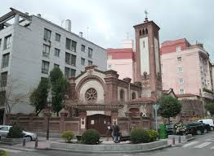
TOWARDS SPRING by Elizabeth Pacey

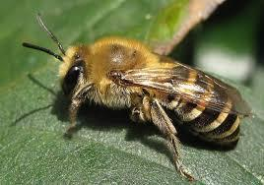
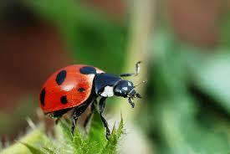
It's amazing how many insects, flowers and small animals are well adapted to survive the harsh winter conditions in the Sierra. This year one of the most notable has been the ivy bee, (collates hedera), known here for some time but only in the UK during the past 20 years. Not particularly liking ivy I have always been quite brutal in cutting it back, but not this year. I was amazed by the huge number of bees feeding on the flower nectar. These ivy bees live in holes in the ground for the bulk of the year, only appearing with the ivy flowers. One 8-foot tall hedge was covered with them, the humming could be heard several metres away as they clambered from fragrant flower to flower. As soon as the flowers had gone the sparrows moved in. The dense foliage of the ivy protecting them from cold and gales as well as predators, so perfect for early nests. A reprieve for the ivy, but only for the moment!
Many neighbours have gardeners with their noisy “sucky blowy” machines to clear leaves and tidy gardens. What a pity that they don´t look under the leaf mould. They would find a host of small animals and insects. Ladybirds are my favourites; waking to crawl gently between the sheltering leaves as they overwinter or emerge early from their larval stage. I have to confess to swooping on them to carry them to the greenhouse in the hopes of them surviving and feasting on greenfly as soon as the sun warms.
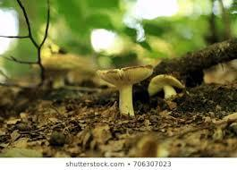
The leaf mould itself is fascinating. When the loose dry top layer of leaves are removed, those sheltered underneath are very damp, hosting valuable earthworms and quietly turning into compost. The white filaments of mould and fungi gently rotting the quite warm vegetation to feed the soil beneath. Wonderful!
Under a totally frozen inch or two of water one or two fish can be seen swimming very slowly from time to time, oblivious to the ice-skating pigeons looking for drinking water. The fish along with frogs, newts and dragonfly larvae live in the layer of mud covering the bottom of the pool, and in brick tunnels supporting water loving plants. They are safe until both they and the heron respond to warmer weather. That most elegant of birds is so beautiful but also a voracious fisherman. Exit a dozen or so of the larger fish and frogs.
The winter frosts are becoming gentler and for some of us the snows are slowly melting. The sun is shining for longer and the leaf buds are beginning to swell. Daffodils, tulips, and snowdrops are appearing and it won't be long before the perfume of lilac fills the air outside the lounge window. The rain may fall but it seems kinder somehow at this time of year. In spring not only does a young man's fancy turn to love (I am old fashioned!) but the birds and the bees also realise that a new cycle of life is beginning and the pace of life begins to gather noise and speed.

THE REALITY OF OUR FAITH 2 by Renmus
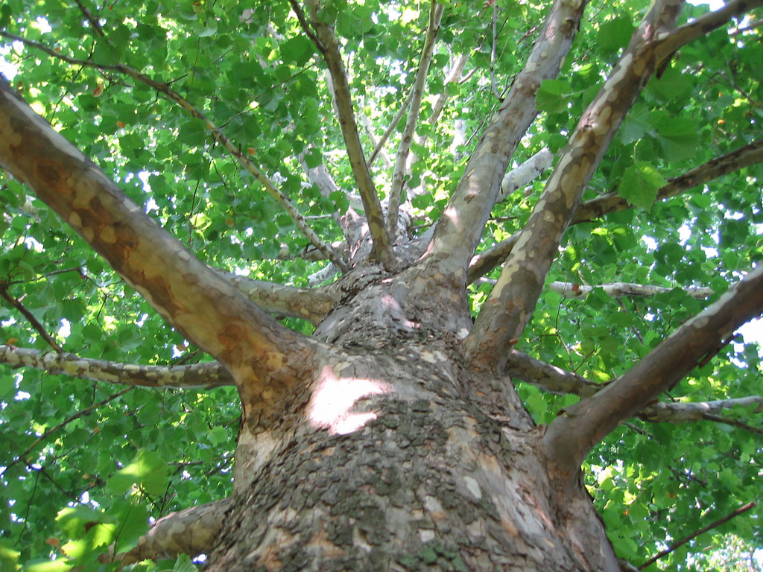
What is it that makes an account of an event ring true? An important factor is evidence that the writer, or the person who reported the event to the writer, was an eye-witness.

When people tell of something that they have seen and heard they usually include minor details of things that they noticed but that do not add anything to the main line of the story. If the account was an invention, such apparent trivialities would be unlikely to appear. In the New Testament the Gospels and the Acts of the Apostles provide a rich crop of such minor additions to the accounts of happenings in the life of Jesus and the Apostles emphasising their truth.

Luke, as well as being a meticulous historian, was a doctor. Was it his custom to record details of his patients and this led him in his Gospel to specify that it was the right hand of the man that Jesus healed in the synagogue? (6:6). Similarly, in recording the arrest of Jesus on the Mount of Olives, it was the right ear of the high priest’s servant that was cut off (22:50). Earlier, on the journey to Jerusalem, the vertically-challenged Zacchaeus climbed a sycamore-fig tree when he wanted to see Jesus (19:4).

In Acts, Luke’s second volume, in his account of the stoning of Stephen, Paul’s (Saul’s) attendance was recorded with the additional information that the witnesses laid their clothes at his feet (7:58).

In chapter 12, he records that Herod arrested some who belonged to the church including Peter and then gives a particularly graphic account of his miraculous escape including another anatomical detail in that the angel struck the sleeping Peter on the side (V.7). When Peter ‘came to himself’ (V.11) he went to the ‘house of Mary, mother of John’ and knocked at the door. ‘A servant girl named Rhoda came to answer the door’ (v.13) She recognised his voice but, instead of opening the door ‘she was so overjoyed that she ran back without opening it’ leaving poor Peter standing outside.
So that he had to knock again. How he must have pounded the door!

All the words in italics above are extraneous to the accounts but give an immediate sense that the teller was present, emphasising the same Peter’s words in his second letter, ‘We did not follow cleverly invented stories when we told you about the coming in power of our Lord Jesus Christ, but we were eyewitnesses of his majesty’.

THE BRITISH CEMETERY IN MADRID by Melissa Pearce
In October last year, I had the opportunity to visit the British Cemetery in Madrid. Despite having lived in the city for 10 years, I had never been aware that it existed!

But this wasn’t a normal visit as a tourist. I was off to work with the Scouts, Cubs and Beavers from the 1st Madrid scout group. And we were there on a mission! To tidy up the gardens and the gravestones, to do some weeding, digging, clearing and arranging pretty stones around the trees. It was great fun and very rewarding. The children got really stuck in and enjoyed making the grounds look neat and tidy. Of course, it wasn’t all hard work and no play! After a well-deserved tea break (well, juice and biscuits for the children!), we played some games and did a treasure hunt to find out more about the cemetery and how it got to be there.

The British Cemetery opened in 1854 – 165 years ago! In those days, it was established well into the countryside outside of the city boundaries and people had to cross over a bridge to get to it. Madrid has grown so much that nowadays the cemetery is part of the city itself.

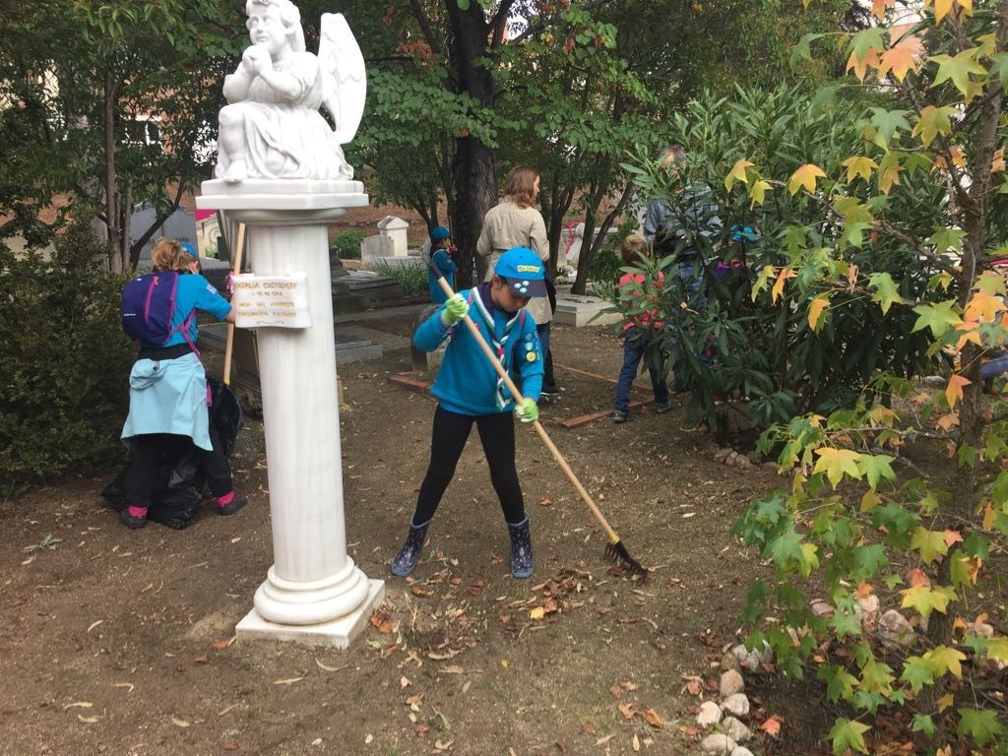
It is owned by the British government. In the beginning it was created for British people who were of non-Roman Catholic faith and weren’t allowed to be buried in a Catholic burial site. And this meant that they could still be buried in consecrated ground. Since then, it has become a resting place for people of many different faiths including Christian, Orthodox, Judaism and Islam all who have lived and died here in Madrid.

There are now approximately 600 graves that house the remains of about 1,000 people who are buried in the cemetery. Half of the remains are of British nationals, and there are also Germans, Americans, Spanish, Swiss and French, with the rest from a further 37 nations.[1]

There are Commonwealth war graves of three British Army personnel of World War 1 and a Royal Air Force officer of World War 2.

The upkeep is carried out by the British community and depends on money from the UK and private donations.
It is a very special place in the city. The garden and monuments are in peaceful surroundings so that family and friends can remember their loved ones.

All the Scouts, Cubs, Beavers and leaders of 1st Madrid really enjoyed their afternoon at the British Cemetery, and we learnt a lot about its history.

The British Cemetery is open to the public on Tuesdays, Thursdays and Saturdays (except public holidays) 10:30 - 13:00.
Calle Comandante Fontanes, 7, 28019 Madrid
http://www.britishcemeterymadrid.com/

WHO WAS Mr WILLIAM EDWIN ALLEN?
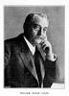
by Carol Alvarez

How many of us know who Mr. William Edwin Allen was? His earlier education was carried out at home, and later completed in Paris, where he attended the College Chapel. Having travelled to Holland and Germany, he subsequently became a resident in Spain, before travelling to Portugal and Italy. During this time, he became an accomplished linguist. He travelled all over the continent as a representative for the Sheffield steel manufacturers Ibbotson Bros. and Co. Then in 1836, Edgar Allen and Co. Imperial Steel works was founded. He was a generous patron of the city of Sheffield and founded the Edgar Allen institute for médico-mechanical treatment. The clinic has survived and is today one of the facilities at the Royal Hallamshire hospital. He also built and endowed the Edgar Allen library of Sheffield University.

The Anglican church in Madrid dates back to the 19th century. The majority of the faithful were diplomats, business people, engineers and their respective families. Services were held at the Embassy coach house, an old palace bought from the Marquesas de Alava in Calle Fernando Santo, and Mr Allen attended whilst living in Madrid. Although never settling permanently in Madrid, his visits nurtured his love for Spain. William passed away at his residence “Whirlow House”on the outskirts of Sheffield at the age of seventy-seven. His Will left instructions for Mr. Cecil Adcock, a British citizen resident in Madrid, that five thousand pounds be destined to constructing a church to serve the non Roman Catholic English speaking community.
Thus we have our dear St. George’s! Thank you Mr.Allen. (Please see the plaque over the main door, as you enter the church.)

IMPRESSIONS OF SYNOD 2019
by Jennifer Effer

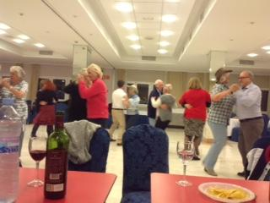
If you read “Sharing the Synod” in last year´s Grapevine, you´ll realise this yearly get together is a heady mixture of serious business: worship and reflection on the Church's role in our lives and a lively meeting of fellow Christians from chaplaincies in Spain, Portugal and North Africa.

On the theme, “Building up the Body of Christ”, Bishop David Hamid reminded us that Christ was also a refugee in his time and urged us to reflect on our Christian identity in the world today.

My Highlights on the “serious” side of the synod:
* A wonderful Bible Study on the Psalms led by the Revd Dr. Richard Briggs, a lecturer at Durham University.
* An inspiring service on healing led by the Rev. Rodney Middleton (Costa Blanca).
* Follow up to Bishop Jorge´s visit last year: the Rev Deborah Chapman (Barcelona) reported on her visit to Peru and the closer links forged. She calls us to volunteer with the church there as they need all the help they can get.

Nitty gritty sessions on the agenda:
* Information on the Church's finances and the reason for raising the contributions made by each chaplaincy to the dioceses. Much discussion, formal and informal followed - like last year!
* Safeguarding must be borne in mind as an integral part of church life.
The “fun” side of Synod is to meet old friends and make new ones from those present and chat over meals or a drink in the evening about each church´s experiences, problems and solutions. We learn a lot too from these informal encounters and maintain contacts with other chaplaincies.

“Market Place” A popular new event with stalls set up where different chaplaincies shared their ideas and practices on fundraising, prayer and support groups, developing communication on places and times of worship and fellowship for wide spread communities. etc.
Farewell event: to our surprise and delight even the bishop and the archdeacon took to the floor for a lively barn dance. Definitely lots of fun!

When I stood in 2017 as one of St George´s two representatives, I had little idea what awaited me but I can only say I look forward to attending my third and last Synod as your representative in 2020 and advise you to “have a go” – it will be a rewarding experience you won't regret!

CAMINO DE SANTIAGO by Richard Boyle

"I very much enjoyed Melissa Pearce's description of walking the Camino in the last number of the Grapevine.
I was delighted to hear that the Monte de Gozo has once again become an integral part of the Camino. When my wife and I visited Santiago some twenty five years ago, the Monte de Gozo, or Mount Joy, was charmingly rural, a small grassy hill with a shepherd and his flock, but very much off the beaten track. In the Middle Ages, pilgrims often travelled in groups, for mutual assistance and as security against robbers.
Mount Joy, apart from providing the very first glimpse of the towers of Santiago cathedral, the resting place of St. James, also provided a challenge. When a group of pilgrims reached the bottom of the hill, those of an active disposition started racing to the top, and by tradition the winner was known thereafter as King, or König, or Roi, a title they retained for the journey home and often beyond.
As a result, many people today called King, or the equivalent in other languages, have no connection with royalty; instead they should give thanks to their fleet-footed ancestor who won the race to the top of Mount Joy! The idea that "I'm the King of the Castle" can also be traced to the Santiago pilgrimage seems too big a stretch to be true!
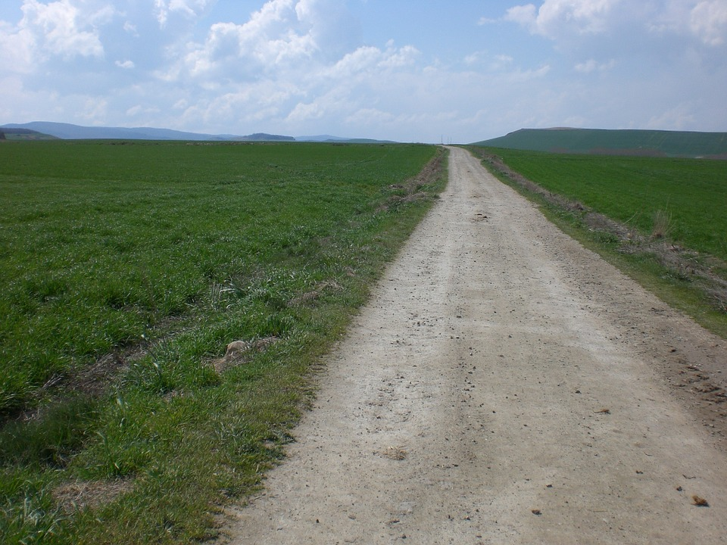

TREVOR THE MILKMAN AND HIS DOG, ALSO CALLED TREVOR (Anon) (For S.P.P.)

Muffled footfall of tough boots on gravel
announced him and the soft clink of pint bottles.
Trevor, milk supplier to Totmonslow,

cast a kind eye on a kitchen draped with
drying clothes such as theatre curtains frame
a stage. There, draining tea from a tin mug,

he dispensed lore from his crate of folk tales:
how he unearthed a garnet ring engraved
Aethelflaed, Lady of Mercia;

how the Wedgwoods, in days before fridges,
built their great ice house in Etruria.
Old soldiers sleeping off their hangovers

will wake to spur indentured retainers
on to freedom from the bonds that bind them
as multitudes flock to their bright banners,

hailing that glad day-spring when the king comes
riding past merchants' mansions, so he told,
to greet a shepherd by a humble fold.

Yet Dilys and my father both agreed
his best story concerned a dog also
called Trevor, so eponymously named

to ease the calling in for lunch by Rose,
his wife, when gamboling in the garden.
And keep all of Staffordshire entertained...

The Church Council:

Reader and Chair: Celia Paterson
The Church Wardens: Anne Cole, Rebecca Rico Irwin
Synod Reps: Celia Paterson, Elizabeth Pacey and Jenny Effer
Honorary Treasurer: Karen Mullins

Elected and Co-opted Members: Carol Skinner, Iain Deuchar, Angela Irwin, Karen Mullins, Rebecca Rico Irwin, Adam Hill, Melissa Pearce

Church Flowers: Louise Bueno
Director of Music
and Organist: Stephen Knight
Deputy Organist: Diana Davies Burr
Secretary Church Council
and Safeguarding Officer: Anne Cole

A PLACE TO FEEL SAFE by Rebecca Rico
Safeguarding is one of those words that we often hear at church but that we don’t fully understand. At least I didn’t. Before I became a Warden at St. George’s I thought it was a matter for Sunday school teachers, child carers and professionals who worked directly with children. Now I realise that I couldn’t have been more wrong.

One of the key terms that you become familiar with when approaching safeguarding is ‘vulnerable’, which refers to the person that is exposed to the possibility of being harmed either physically or emotionally.

Although you probably wouldn’t define yourself as vulnerable, I am sure that at some point in your life, or in certain situations, you have felt exposed. Maybe you were walking home on your own one night, or you were involved in a conflict at work where you were in conditions of inferiority. How did it make you feel?

When I moved to Puerto Rico three years ago I went on a trip to one of the nearby islands. Just as the ferry opened its doors and the line started to move, I fainted. All I can remember is that, when I opened my eyes, I was being moved by some strangers and I was unable to take control of the situation. Luckily for me, I wasn’t alone, and my friend made sure that I was safe at all times.

Sadly, not everyone has someone watching over them to keep them safe. Domestic violence, child abuse, or elderly neglect are just some of the issues that silently surround us.

As members of a community we can help those in a vulnerable position by preventing harmful situations, protecting them from potential threats, and reporting any abusive conduct to the competent authorities. We can make our church a place to feel safe.

The Church of England’s safeguarding policy is based on 6 commitments:

- Promoting a safer environment and culture
- Safely recruiting and supporting all those with any responsibility related to children, young people and vulnerable adults within the Church
- Responding promptly to every safeguarding concern or allegation
- Caring pastorally for victims/survivors of abuse and other affected persons
- Caring pastorally for those who are the subject of concerns or allegations of abuse and other affected persons
- Responding to those that may pose a present risk to others

In short, safeguarding teaches us how to identify threats and gives us the tools to neutralise them.

Khalil Gibran once said, ‘Safeguarding the rights of others is the most noble and beautiful end of a human being.’

If you’d like to make protecting others your end, why not start by taking the safeguarding online trainings on the Church of England website? If you have already completed the course, join us for our workshop on Saturday 18th of May 2019!

THE EASTER SACRIFICE by The Editor

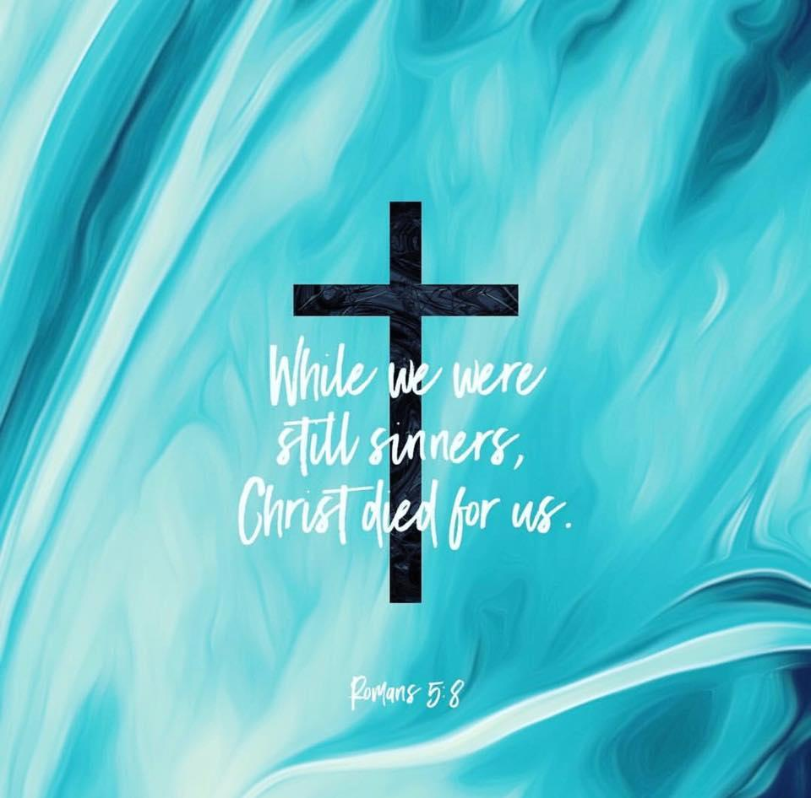
Sacrifice was Sir Elton John’s belated first Nº U.K. single. An unusual title for a successful release in the fast-moving, and ever-changing world of Pop Music.
Whether or not it is as ´simple´ as John´s song referred to it the word is much bandied and often only broadly understood. Christians, though, still commonly refer to Christ's ´sacrifice´, celebrated each year during the sombre Lent and festive Easter observances. We make reference to the sacrifice of God becoming man, to His ´human´suffering, and to the ultimate sacrifice offered on the Good Friday cross.

As Christians, we are offered salvation thanks to that once-made sacrifice. In response, we are called to believe in Him, and to follow His example.

In all aspects of our lives, we all make sacrifices, however small they may seem. Likewise at St George´s, we sacrifice time, energy, our cooperation at events, and money, as we are able. Thanks to those sacrifices by fellow-believers down the times, we have a lovely church where Christians from all over the world are able to enjoy the services, and the fellowship the church offers.

Time moves on, but the needs to maintain this church both physically and spiritually, require the efforts of all who worship here, however briefly or sporadically. To ensure that we are able to practice our beliefs together in the church we have inherited, we all need to consider how much we give in offering energy, time and money. To ensure that the Church is still here, and in good shape, in the future, we may be able to give a little more in return for what we have received.

OUR NEXT LOCUM- John W. Kilgore
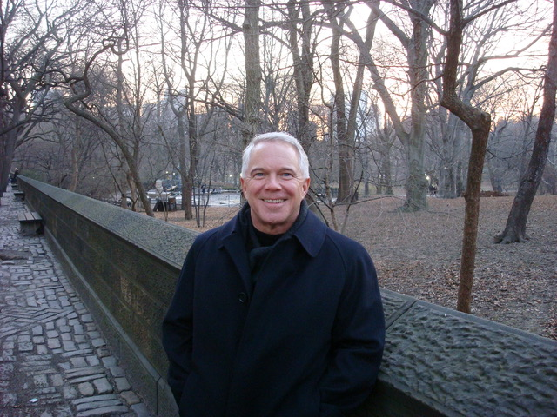
The Reverend Canon John W. Kilgore, M.D. will be joining us as our interim chaplain beginning Palm Sunday. He relates that he is very happy and excited to be serving at St. George’s Madrid after a hiatus of more than forty years! While studying at La Universidad Complutense during a semester abroad program in 1974 he worshipped at St. George’s and remembers Father Basil Ney, and perhaps a few parishioners. In the interim he has travelled many times to Madrid and throughout Spain and has worked hard to maintain and improve his command of Castilian.

Fr. John has enjoyed a distinguished career as an invasive cardiologist and was also deeply involved in hospital administration, leading the cardiology divisions of several hospitals in a Catholic health care system in the midwestern part of the United States. Long involved in the Order of St. John (also known as St. John Ambulance) and being a Knight in the Order, he experienced a sense of call to the priesthood while doing work with St. John Ophthalmic Hospital in Jerusalem and its lovely patients. He subsequently began a bi-vocational lifestyle, having been ordained in 2003 and serving as both priest and physician since that time. He continues his bi-vocational work both in the United States, where he serves as a leadership advisor to health care executives, and in Europe where he has served as supply and interim priest in a variety of parishes. He plans to be among us for the duration of our interim period, helping shepherd us to the next chapter in the life of St. George’s Madrid.

Please welcome him warmly!

