GRAPEVINE

Autumn Edition
2019

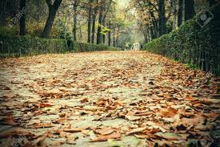

St George’s Anglican Church
Nuñez de Balboa, 43
28001 Madrid
(Metro VELAZQUEZ – Line 4)

Services

Sundays 08:30 am Holy Communion
10:00 am Family Eucharist
10:00 am Godly Play (Sunday School)
11:30 am Sung Eucharist
11:30 am Sunday School (as announced)

Fifth Sundays 08:30 am Holy Communion
11:30 am United Service
No Sunday Schools

Wednesdays 19:30 pm Evening Prayer
Fridays 10:00 am Holy Communion

Tel: +34 91 576 5109
Email: info@stgeorgesmadrid.com
Web site: www.stgeorgesmadrid.com
Locum: Revd Canon John Kilgore
Follow us: www.stgeorgesmadrid.com
OR facebook.com/stgeorgesmadrid

MESSAGE FROM OUR LOCUM CHAPLAIN

A VIEW FROM THE COSTA DEL SOL
First of all, a big thank you for all the fellowship and care you have showered upon me during my two recent visits. You have been wonderful and I look forward to being invited again in the future.
Iain invited me to write something for Grapevine, so I thought a little taste of the Ecumenical work here in Fuengirola, which began in 1973 may interest you.
Lux Mundi was founded in 1973 by the Diocese of Malaga, and the Jesuits, with a commitment to unity and the service of others. It is staffed by many teams of volunteers from various churches and a warm welcome is given to all regardless of race or creed. The centre has a light and airy lounge plus a patio where you can purchase refreshments. (I work in the coffee shop).
There are many facilities throughout the year.
As a Charity they collect non-perishable goods plus clothing and bedding for the local Caritas. Presents are given out at Christmas to children and elderly people.
On Tuesdays and Thursdays, Cocina Solidaria provide food and clothes for the homeless.
Another service is wheelchairs and walking aids for a small charge.
The staff and volunteers are always willing to help those who have problems by listening and giving practical help such as filling out forms..
Various groups also use the centre for AA, NA, University of the Third Age and art classes.
Recently the Boutique has been re-ordered for selling “new to you “ clothes and other small items. In the lounge there is also a library where you can buy books , DVDs and CDs, all at 50 cents a copy.
Is your Spanish lacking confidence? You can join a beginners class or attend the Intercambio Group - conversation in both Spanish and English.
There is a small chapel, which is mainly used by the Church of Scotland.
There is also something new – excursions play a big part of the fellowship, and one can easily make new friends.
*************
Whilst our joint services have played an important part in our Ecumenical Journey, now over 100 years, working together, doing various things together, advances Our Lord’s Prayer - that all may be one. Remember, Jesus didn't pray that we should be “all the same”.
Fr Peter Ford, OGS

THOSE KIND SOULS by Carol Alvarez
Times have changed. Jumble sales, bazaars, and other social events are not as buoyant as they used to be. We know this. There's no sense comparing, it will get us nowhere and we're just wasting precious time.
We must keep up with today's times and demands, and carry on working together towards securing the future of our Church to keep her standing high, steady and strong.
We need new ideas, new projects and urgently; strong eager hands on board.
It is not easy to organise a bazaar. Our events need to improve . I'm not sure if all of us realise how much hard work goes on behind the scenes.
Why is it, I always seem to see those same five ladies, who have been doing their bit for the past 40/50 years? "Bless them!" . But we cannot expect these KIND SOULS to carry on lugging tables or bags around. We cannot thank them enough, or indeed those kind members who donate gifts for the raffle or tombola, or those ladies who bake, sew, or make jams. We thank you dearly for always being there.
Back in the fifties we were most probably the pioneers in regards to jumble sales and bazaars. We were given gifts from companies, lovely articles from expats coming and going, plus the church had a booming younger congregation. Definitely, back then everything was much easier for everyone; economically and socially.

Today we don't receive any help from any source whatsoever. This must be made clear: "It's just us!"
Did you know there are members who make and sell sandwiches and cakes at our events to make money to buy raffle prizes.
Did you know there are members who come in and sort through donated clothes weeks beforehand, some of which are taken home and washed? A high percentage we cannot sell, and these have to be taken to a recycling point, which also has to be arranged. I could go on with many more examples which most possibly, a lot of people are just not aware of.
Nowadays, second hand shops have bloomed up all over, the chinese can sell you a brand new item for a couple euros. Every week there's a mercadillo somewhere. We therefore cannot just sit back and watch. We must improve, and make our events look attractive. Our sales have decreased by 30% in the last few years, and probably 50% if we go further back .
We are open to any new ideas you may have, and might like to share to help us improve future events. We also need to get back on track with our fundraising projects, which have seen a drastic drop over the years
St. George's will be celebrating its one- hundredth anniversary of our consecration in 2025 which also involves a great deal of preparation. As you can see there is a lot to do!
The Church helps us all in so many different ways. How can we repay that kindness? It's not just about putting an extra euro in the collection, which of course we do appreciate. It's about the church's maintenance. It's about how can we help and care for our Church.

We should, and must do this together. It will not work otherwise. As you all know, this year we have had to put a new drainage system in, which was a very costly operation.
We also have renewed the bathroom, but there are still many important and necessary repairs that must be done.
If you can lend a hand in any way, just speak to any of the old timers, and they will guide you to the person who can explain where and how you can lend a hand.
Please give this a serious thought. Between us all, I know we can make this work.

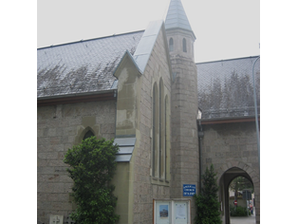

CHURCH GROWTH by The Editor

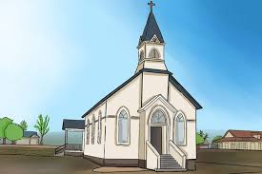

Surfing the web recently, I came across an interesting article on Boxcast about Church Growth and thought that this might be a good moment for us all to reflect on some of the aspects they touched on.
The article states that in 60% of Protestant churches fewer than 100 worshippers make up the congregation on a given weekend. At a so-called “mega-church”, over 1,000 adults attend worship every Sunday. Even if this is not our major aim, we do want our ministry to reach out to as many people as possible. So how should we go about making our church more attractive to people of all ages.
Despite falling numbers in most congregations, a majority of occasional church-goers seem to imagine that being baptised and loosely following the most important commandments is commitment enough to be considered Christians.

When Jesus committed his first disciples, calling them to “Follow me”, some excused themselves on the grounds of inconvenience.
Only a selected few truly obeyed His call and then made a 24/7 commitment that eventually led to opposition, persecution and early death.

Only by listening to our teachers and studying His Word in the New Testament, can we hope to complete the task successfully. It may be hard to see this happening before our eyes in a city like Madrid. A former Anglican leader, Archbishop Temple, said that ‘The Church is the only society that exists for the benefit of those who are not its members’

In the Lord´s prayer offered to the first disciples, Jesus told us to ask the Father that His will be done. It is necessary to find out what His will is and be part of the massively exciting task of making His Kingdom come. It is moving out with the Gospel in tow, to meet others that will bring others into our church. It is only by sharing the wonderful story that we believe, and live for, that will attract others into our churches on a Sunday morning to worship God and thank Him for what He has done.
(Please check out the following link which inspired my editorial)
https://www.boxcast.com/blog/3-easy-ways-to-grow-your-church)

THE LAITY IN THE PARISH by Miguel Sanchez
As time passes, it has become clear that the weight of the faithful laity in the life of the Parish has dramatically increased. This can be explained both by the decrease in the number of those ordained to the priesthood but above all by a new awareness of the dignity of the faithful laity in the life of the Church and of the responsibility they share, together with their bishops, priests and deacons, in the mission of the Church. All faithful Christians, by having received Baptism, participate in the priesthood of all those baptised which is linked to the priesthood of the same Christ. Every baptised person has a share in the total mission of the Church. Every Christian is called to evangelise, according to the person’s state of life. Thus, lay people, as baptised in Christ’s death and resurrection, are sharers in the priestly, prophetic, and kingly mission of Jesus Christ. Certainly, the faithful laity are not only called to participate in the mission of the Church. They are not simply labourers who work in the vineyard, but a part of that vineyard. As Jesus says, "I am the vine, you are the branches" (Jn 15:5).
They are called both to sow and to reap the seed by their word and life in the secular world. This is why a secular character is peculiar to the laity, as it were, the faithful laity are primarily called to evangelize the secular order. So, as John Paul II states, “… for the lay faithful, to be present and active in the world is not only an anthropological and sociological reality, but in a specific way, a theological and ecclesiological reality as well” (CL 15). Thus, we can say that the essential role of the laity is the vocation to bring the spirit of Christ into the secular life from within, i.e. into the family, work, trade, politics, mass media, culture and national and international relations. To bear witness to Christ’s call to be reconciled with God and to become channels through which the Spirit of Christ can work in the world. The lay people can certainly cooperate with their priests, but they are not mere helpers or the clergy. To see them as such is a huge misunderstanding. It is one of the roles of the clergy to equip and prepare the laity to develop and accomplish their own specific mission. Clerics and laity cooperate in inner-Church affairs, however in the secular area, the laity are to take on full responsibility.
Sadly, I have to acknowledge that ignorance on the part of some clerics on what the Church teaches as distinctive of the lay apostolate can be an impediment for the lay people to accomplish and realize the tasks specifically entrusted to them. Also fear on the part of the clerics can be another factor to hinder the labour of the laity in the Church. Another factor that we need to carefully take into account is the fear of the unknown shown when we hear: “There is no need to change. The clergy have given good leadership in the past and we had better not experiment with new ideas”. This fear can be found both among the clergy but also among the laity; and according to my experience in England it is more common among the laity than among the clergy. Finally, I have heard many times (and this is another fear shared by some clergy and laity) that the laity do not have enough theological formation. Well, perhaps, but if so then it is the priest’s responsibility to give it to them.
So, what is the role of the priest regarding the laity? From clerics, the laity receive the strength given by the sacraments and by the dynamic exposition of Church doctrine, and then the encouragement to evangelize the secular order. Bishops and priests are the pastors in the Church. The “lay apostolate” has nothing to do with a power struggle in the Church. When we say “Church,” we refer to all the baptised members of the congregation, that is, the laity (who are 99.9 percent of the Church), and the clergy. Jesus Christ is our Master. All of us, bishops, priests, and laity are servants; brothers and sisters in the service of Christ and our neighbour.
This is the appropriate time for the whole Church to wake up and take a step forward. It is a time when the labour is massive and the labourers ever fewer and fewer. It has become of the utmost importance that the laity assume an intentional and active Christian lifestyle. The Church needs the laity to be aware of their vital role and of the importance of their mission. Both the clergy and laity need to be intentional disciples of Christ. This is especially true for members of the laity. Lay people, who fully live their lives in the secular world, can, and should, be a more effective means of evangelization and of change. Precisely by not being members of the “established church” they can challenge their peers with their lives and avoid suspicions on the part of non-believers. I have to acknowledge that I was more effective in bringing people to church before I was a priest than since my ordination. This is why I would like to invite you to not to hide your faith and keep up the good job of sharing the Good News in the context in which you live.

RECENT & FORTHCOMING EVENTS

Thursday 19 September British Benevolent Fund event
Saturday 21 September Book sale

Saturday 5 October Jumble sale
Sunday 10 November Remembrance Day Service
Saturday 14 December Christmas Fair

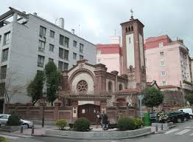

The Church Council:

Lay Chair: Jenifer Effer
Secretary Church Council: Adam Hill
The Church Wardens: Anne Cole, Rebecca Rico Irwin
Reader, Diocesan Synod Rep and
Ferede Secretary: Celia Paterson
Synod Reps: Elizabeth Pacey and Jenny Effer
Honorary Treasurer: Karen Mullins
Safeguarding Officer: Melissa Pearce

Elected Members: Carol Skinner, Patricia De Juanes, Iain Deuchar,
Diana Grayland, Adam Hill, Angela Irwin, Karen Mullins,
Melissa Pearce, Gillian Trotter Park

Other Appointments:
Administration Officer; Liz Mason Church Flowers: Louise Bueno Director of Music and Organist: Stephen Knight Deputy Organist: Diana Davies Burr Data Protection Officer: Anne Cole
Grapevine Editor: Iain Deuchar
St George ́s Committees

Standing Committee: Chaplain, Wardens, Secretary and Treasurer.
Fundraising Committee: Angela Irwin, Carol Skinner
Fabric Committee: Carol Skinner, Gillian Trotter-Park, Rebecca Rico
Business Committee: Gillian Trotter-Park, Melissa Pearce
50 AT 50!
by Melissa Pearce
Earlier this year, my husband celebrated his 50th birthday, and he wanted to mark this special mid-life milestone by doing something a bit different. So rather than going out and buying a Ferrari, he decided to take on the challenge of a 50-kilometre coastal walk race!!! It was an organised event across the Jurassic coast in South Devon, with only 14 hours to complete it! And that’s not all… He wanted to rope in his friends (and wife!) to join him achieve this 50 at 50!
The walk was organised to take place on the weekend of the summer solstice and I presumed I would be able to make the most of the many hours of daylight. Six of my husband’s best friends drove down from Essex, and my hubby and I flew over from Madrid. We all met up in a holiday caravan park on the beautiful South Devon coast.
The morning of the event arrived and we all had to be up by 4.30am! A coach took us all from Exmouth to Lyme Regis in Dorset. Lots of people of various ages were taking part and we all convened at a Rugby Club, where we were given refreshments, a t-shirt, a number and the very important safety briefing. At 8 o'clock, on the dot, we were off, down the steps – many more of which were yet to come – to the seafront.
A lot of the competitors, who started running, had soon disappeared into the distance, but we were happy to walk at a steady pace. All seemed fine to begin with, but soon we had left the vast, flat expanse of the seafront and were now in thick forest climbing hundreds of steps up and hundreds of steps down. Compared to the day before when it had been very hot all day, the weather was now perfect; cool if a bit misty. It had rained the week before which had left the steps a bit muddy and a little slippery, so we had to take care.
For the next few hours, we walked from the beaches at sea-level right up to the highest peaks and then back down to sea level again. Over and over, up and down steps which really took their toll on our knees, thighs and feet. Of course, this lent itself to some spectacular views and the reward for reaching the top of the cliffs was being able to take in the stunning and seemingly never-ending coastline. It also provided a lot of variety; one minute we were in forests, and the next in a field of cows; from walking on pebble beaches to wading through long grass; from pounding up and down slippery wooden forest steps to transversing almost vertical grassy fields leading up to the peaks of the cliffs. One extremely steep side has even been given the nickname ‘Cardiac Hill’ by the regular walkers.
There were three checkpoints along the route where we had to check in by a particular time, otherwise the organisers wouldn’t let you continue. The first one was on the seafront at the next big town of Seaton and the second one at a sailing club in Sidmouth. By the time my husband & I had reached the latter, our (obviously much fitter) friends had already broken away and had gone on ahead. We heard from one of the helpers that they had passed through this checkpoint about an hour earlier.
It was also there that we met a couple who were attempting the 100-km walk! They had already achieved an incredible 80kms, having started at 9pm the night before and walking through the night. They must have been shattered. They decided, there and then, to call it a day as they were losing pace and probably wouldn’t make the next checkpoint in time. Nevertheless, we congratulated them on their achievement. It really was arduous, and they had done amazingly well to reach that far. With that, we realised we needed to get going, otherwise we weren’t going to make it either!
Before long, we had caught up with one of our friends on another cliff top and he was really struggling with pain in his legs, knees and hips. He was using a walking stick and had dropped behind the rest of our group. After an enormous amount of encouragement, we managed to motivate him enough to join us and at least make the final checkpoint which by now wasn’t too far away.
The last checkpoint was at Budleigh Saltertonwhere we had to check in by 7.30pm in order to qualify to finish the race. As we came down the side of the hill, we could see the checkpoint in a car park ahead of us… but then we realised we had to walk all the way upstream to cross the river and come down the other side before we could reach them! Time was running out, and one of the organisers came to ‘spur us on’. “You’ve got about 5 mins” he said. I can’t believe it now, but we started running… having already trudged 40 kilometres. Our friend was limping, we were all so tired, yet we were running to make the last checkpoint – just so that we could walk another 10kms and make the finish!!
We did reach the checkpoint in time, and then we just had the last stretch to do. We were convinced that our friends ahead of us had probably already finished. This made us determined to get to the finish line ourselves. So after a quick refreshment and a sort out of our bags, feet, shoes and walking sticks etc. we set off once again.
One of the hardest parts towards the end, was having to trek right past the caravan park where we were staying. It felt so tempting to divert into the comfort of our caravan, or even the clubhouse! But we didn’t give in and continued up the last hill. At this stage, a ‘sweeper’ from the organising team came and joined us. It was his job to make sure there was no-one left behind. Yes, we were the last, but were still going!! He told us that there had been quite a few people who had dropped out, which gave us that last burst of energy. He was very good at chatting away and taking our minds off our aches and pains.
Dusk was approaching and we were now on the final, but very long, promenade of the Exmouth seafront. Just a few minutes to go! Then we saw it – the finish line was in sight! As we came in - the last 3 of the entire event - we got a round of applause from the helpers and from our friends who had already finished two hours beforehand! It was such a great feeling of achievement, especially when we received our medals which were of Olympic size and weight!
We had done it – yes, albeit just inside the allocated 14 hours – but we had done it! 50 at 50!
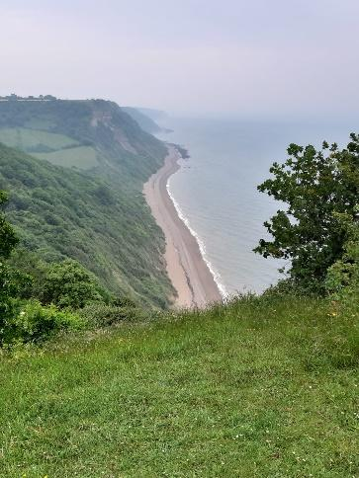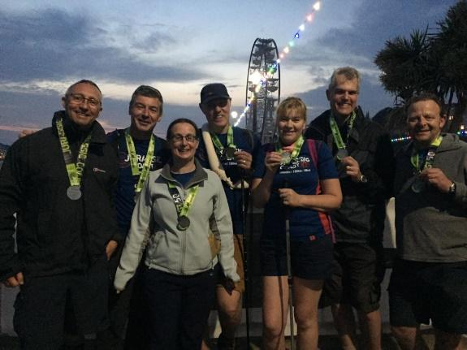
The Jurassic Coast 50k & 100k walks are organised by Climb South West and the next one will take place 20th-21st June 2020.
https://www.climbsouthwest.com/events/jurassic-coast-100/

SERVICES AT ST GEORGE´S

Sundays:
08.30 Said Eucharist (1st, 2nd, 3rd & 4th Sundays)
10.00 Family Eucharist (All-Age Service or Sunday School for Children)
11.30 Sung Eucharist

Sunday (5th of the month):
08:30 Said Eucharist
11:30 United Service
Wednesday: 19:30 Evening Prayer
Friday: 10:00 Eucharist

In addition a monthly Sunday evening sung Eucharist service is held at the “La Chimenea Chapel” at El Escorial.

